Same Ends Finder
This is a console application in Python that finds if an English word begins and ends with the same phrase or not.

Distribution File
SameEndFinder-0.0.1-py3-none-any.zip - Unzip this to your Python projects folder and run SameEndFinder-0.0.1-py3-none-any/SameEndFinder/main.py
SameEndFinder-0.0.1-py3-none-any.whl is also available. I face some issue while trying to install using pip install --no-index --find-links <path to the.whl file on local disk>; could not figure out a solution. Also, kindly note that the entire development was done on my Android phone with qpython3 app and that no testing could be done on another device as no other system was available.

Design

sameEnds(str)
This is the core function. It contains the logic to check the input word, str. Since this is a small utility, I decided to stick to a function.
Location: /sameendfinder.py

Additional files
/main.py
Contains the call to sameEnds function in an ever iterating loop, that accepts the letter,'q' as a command to quit the program.

Tests
Location: /tests/TestSameEndFinder.py
Contains necessary test cases for the application. These are written on 'unittest' package.

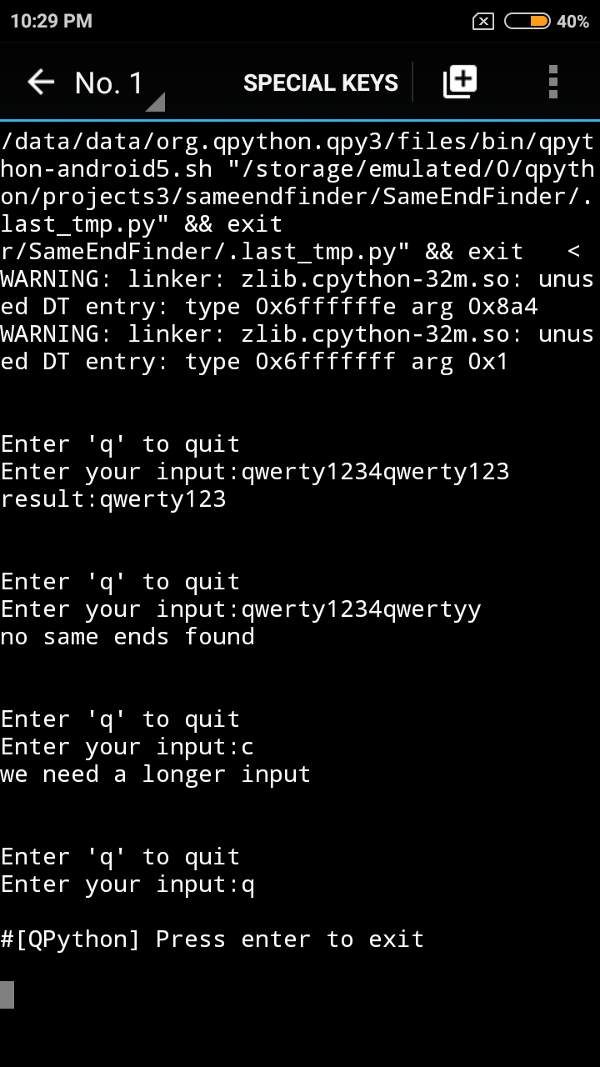
Sample Screenshots
